**J.Madhu**

**192011397**

 

**SAVEETHA INSTITUTE OF MEDICAL AND TECHNICAL SCIENCES**

**SAVEETHA SCHOOL OF ENGINEERING**

**Department of Computer Science and Engineering &**

**Information technology**

**CS016 - Database Management Systems** **Lab Manual**

# J.Madhu

# 192011397 INDEX

|  |  |  |
| --- | --- | --- |
| **S.**  **No.** | **Exercises** | **Page No.** |
| 1 | DDL Commands – CREATE, ALTER, DROP |  |
| 2 | DDL Commands with Constraints – PRIMARY, FOREIGN KEY, UNIQUE, CHECK |  |
| 3 | DML Commands – INSERT, SELECT, UPDATE, DELETE |  |
| 4 | SELECT with various clause – WHERE, pattern matching |  |
| 5 | SELECT with various clause – BETWEEN, IN, Aggregate function |  |
| 6 | SELECT with various clause – GROUP BY, HAVING, ORDER BY |  |
| 7 | SubQuery & Correlated Query |  |
| 8 | Joins – EquiJoin, InnerJoin, OuterJoin |  |
| 9 | VIEW, INDEX, SEQUENCE |  |
| 10 | Simple programming exercises using CASE, IF, ITERATE, LEAVE, LOOP |  |
| 11 | Simple programming exercises using REPEAT, WHILE |  |
| 12 | TCL Commands – COMMIT, ROLLBACK, SAVEPOINT |  |
| 13 | DCL Commands – GRANT, REVOKE |  |
| 14 | Procedures |  |
| 15 | Function |  |
| 16 | Cursors |  |
| 17 | Triggers |  |
| 18 | Database Connectivity – Using PhP & MySQL |  |

**192011397**

**CREATING TABLE**

**SYNTAX:**

create table stud(regno int,stud_name varchar(10),DOB int,Gender varchar(2));

desc stud;

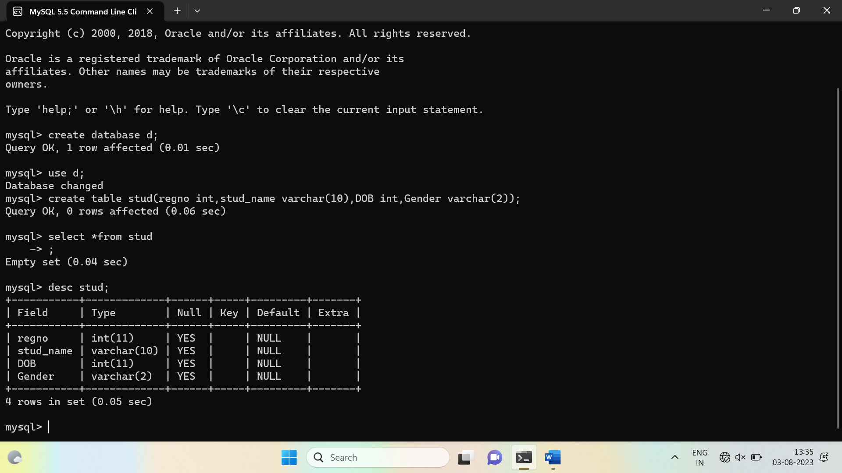

**INSERTING VALUES**

**SYNTAX:**

create table stud(regno int,stud_name varchar(10),DOB int,Gender varchar(2));

insert into stud values(397,'madhu',2001,'m');

insert into stud values(431,'pranith',2001,'m');

select * from stud;

192011397

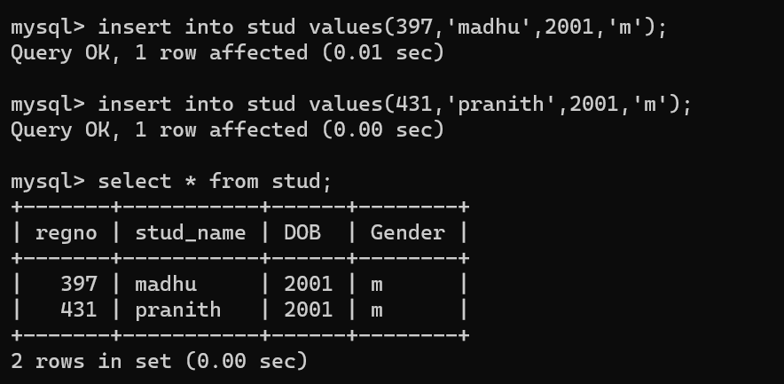

**ALTER TABLE**

**SYNTAX:**

alter table stud ADD age int;

insert into stud values(397,'madhu',2001,'m',20);

insert into stud values(431,'pranith',2001,'m',20);

select * from stud;

**I** 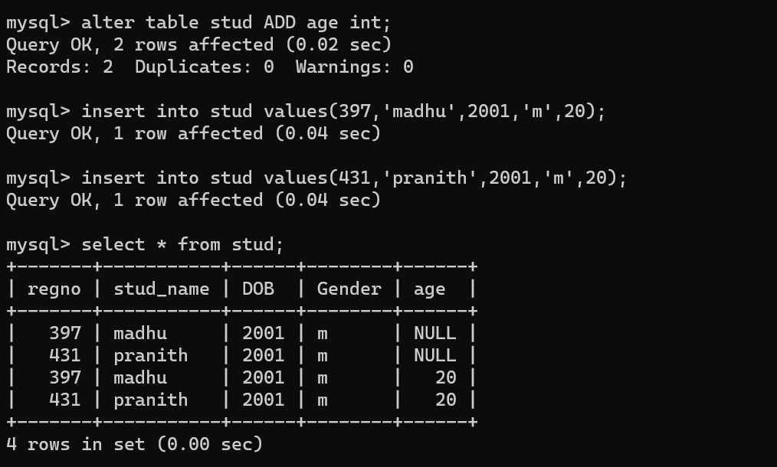

**UPDATING VALUES IN TABLE**

**SYNTAX:**

update stud set age=22 where regno=431;

select *from stud;

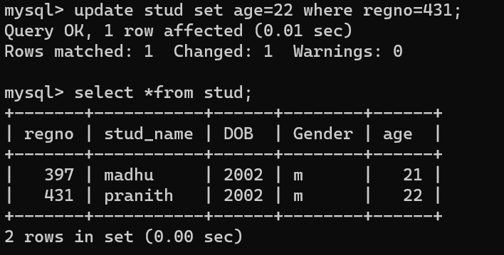

**DELETING VALUES IN TABLE**

**SYNTAX:**

delete from stud where stud_name='pranith';

select *from stud;

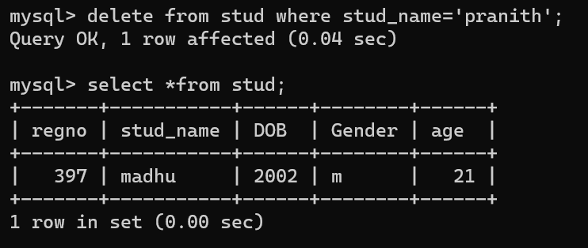

**SELECT**

**SYNTAX:**

select stud_name from stud;

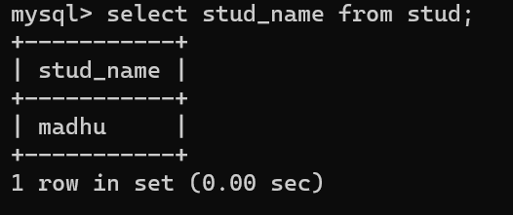

**TRUNCATE**

**SYNTAX:**

truncate Stud;

select *from stud;

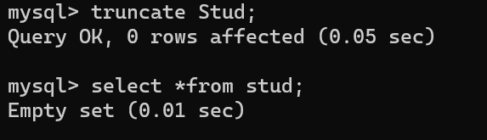

**DROP**

**SYNTAX:**

drop table stud;

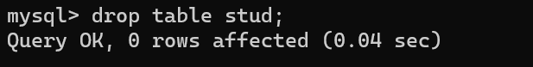

**VIEW TABLE**

**SYNTAX:**

create view employee_view as select emp_name,ID_no and dept from employee;

select *from employee;

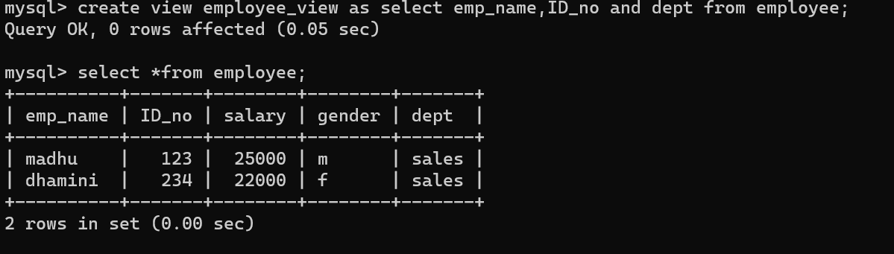

**INDEX,SEQUENCE**

**SYNTAX:**

create index emp_name on employee(emp_name);

show index from employee;

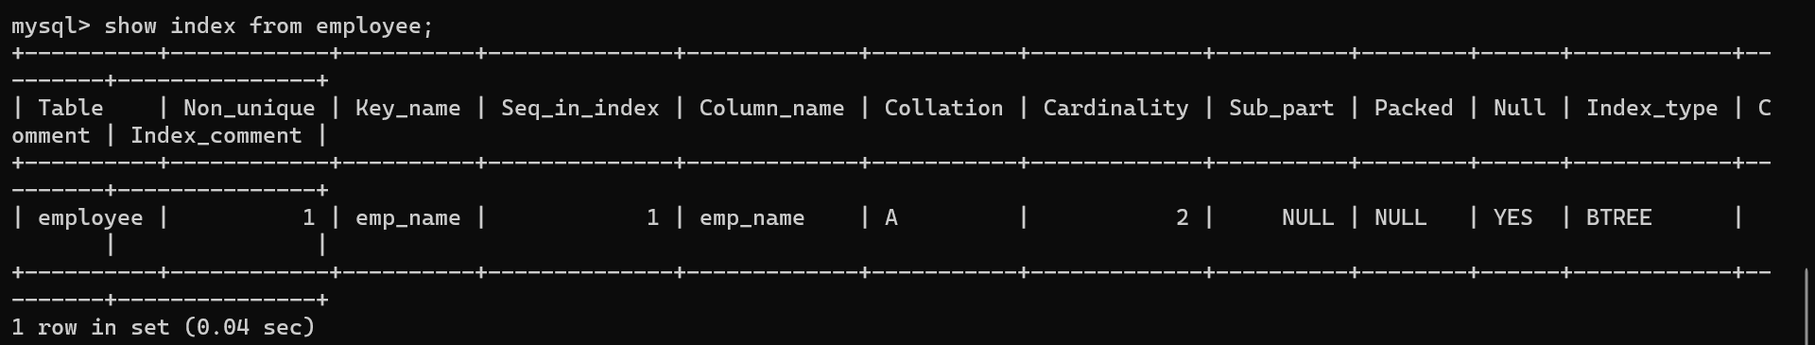

**SELECT WITH VARIOUS CLAUSE_BETWEEN,IN,AGGREGATE FUNCTION**

**SYNTAX:**

create table student(student_name varchar(10),course varchar(10),semester varchar(10),marks int,subject varchar(10));

insert into student values('madhu',1,'sem1',90,'maths');

insert into student values('dhamini',2,'sem1',97,'chemistry');

insert into student values('chandra',3,'sem1',93,'physics');

insert into student values('kishore',4,'sem1',85,'biology');

select *from student;

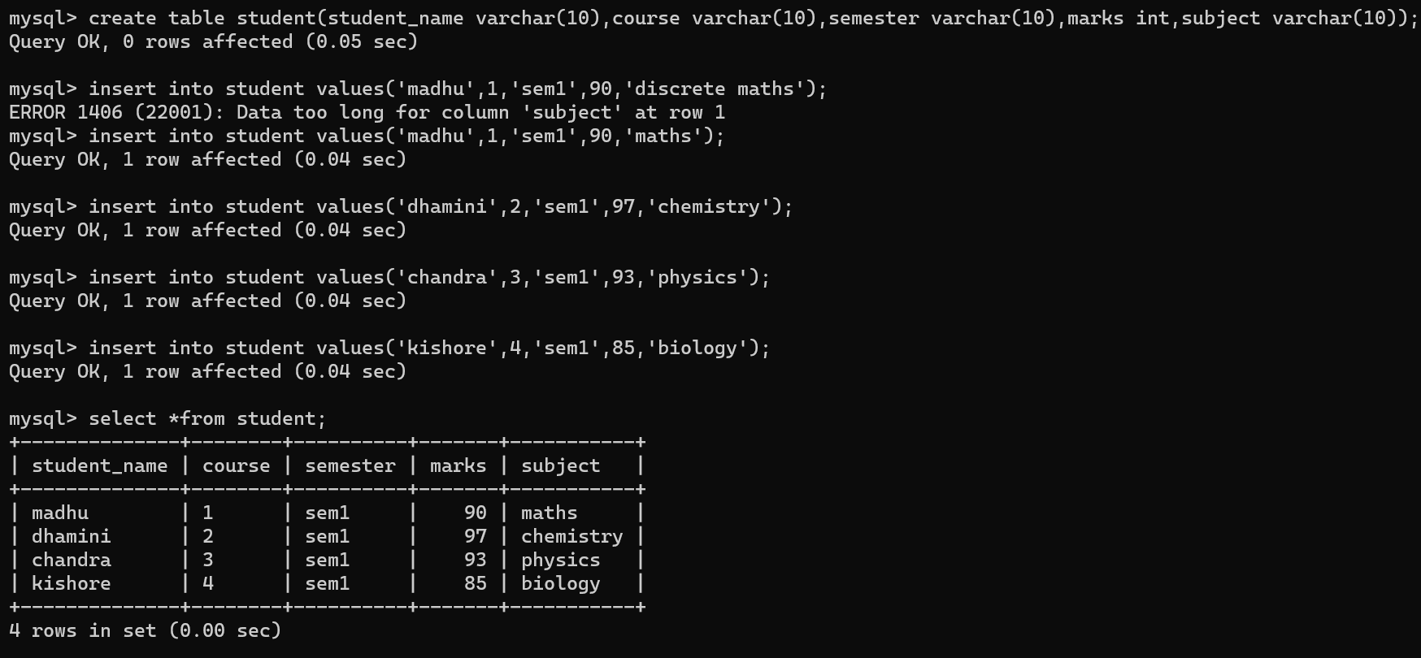

select min(marks)from student where course=1;

